A

PROJECT REPORT ON

“Website of Kolhapur Talim”

SUBMITTED TO

D. R. K. COLLEGE OF COMMERCE, KOLHAPUR (AUTONOMOUS)

FOR THE PARTIAL FULFILLMENT OF DEGREE OF

BACHELOR OF COMPUTER APPLICATION BCA-II, SEM-III (2024-2025)

UNDER THE FACULTY OF COMMERCE AND MANAGEMENT

BY

Vishal Namdev Salunkhe

Yash Sagar Machale

UNDER THE GUIDANCE OF

Mr. S. T. Mahadik

DEPARTMENT OF COMPUTER APPLICATION

D. R. K. COLLEGE OF COMMERCE, KOLHAPUR

(AUTONOMOUS)

2024-2025

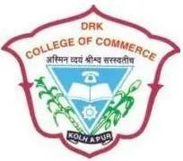
DEPARTMENT OF COMPUTER APPLICATION
D.R.K. COLLEGE OF COMMERCE , KOLHAPUR
(AUTONOMOUS)

CERTIFICATE

This is to certify that the website entitled “WEBSITE OF Kolhapur Talim” which is being submitted here with for the partial fulfilment of degree of Bachelor Of Computer Application (B.C.A.) as laid down by D.R.K. College of Commerce , Kolhapur(Autonomous) is the original work completed in this college by Mr. Yash Sagar Machale and Mr. Vishal N. Salunkhe under my supervision and guidance and to the best of my knowledge has not submitted to any other institute, university or examining body.

Place:

Date:

Mr. S. T. Mahadik Examiner Mr. S. T. Mahadik
(Project Guide) (co-ordinator,BCA Dept.)

DECLARATION

We hereby to declare that, this report entitled “WEBSITE OF Kolhapur Talim ” , Development in HTML and CSS in the year 2024-25 under the Guidance of Mr. S. T. Mahadik is our original Work and has not previously been submitted to any university or examining Body for the award for any degree.

We have referred the books and websites given in bibliography during the Development of the project and have not copied any of written material or Its part thereof. This project is purely our own and on our merits.

This work is humbly submitted to D.R.K. College of commerce , Kolhapur (Autonomous) for the partial fulfilment of Bachelor of Computer
Applications.

Place: Kolhapur

Date:

Seat no. | Name | Signature
43056 | Mr. Yash Sagar Machale
 | Mr. Vishal N. Salunkhe

ACKNOWLEDGEMENT

We would like to extend our sincere gratitude to everyone who supported And contributed to this project. The first and foremost person we would like to thanks is our guide Mr. S. T. Mahadik for his keen interest, valuable guidance and continuous encouragement throughout the development of the project work. we express our sincere thank of all faculty member of the department for their valuable suggestions and support.

we express our sincere thanks to Dr. Varsha Maindargi ,The I/C Principle ,D.R.K. College of Commerce ,Kolhapur (Autonomous) and Mr. S. T. Mahadik, the co-ordinator, Department of B.C.A for making us available with the laboratory facilities.

Additionaly , we are greatful to our family for their unwavering support and encouragement during this journey. Also, we would like to express our sincere gratitude to those who have helped us directly and indirectly in our project.

Place: Kolhapur

Date:

Seat no. | Name | Signature
 | Mr. Yash Sagar Machale
43056 | Mr. Vishal N. Salunkhe

INDEX
Sr.  No | Subject | Page  No
1 | Introduction to Project :  - Introduction  - Objective  - Scope
2 | Tools and Technology :  - About HTML, CSS, & JS  - Hardware and Software requirement
3 | System analysis –  - Tree diagram  - Data collection
4 | System design –  - input design and its sample
5 | Limitation Suggestion :  - Limitation  - Suggestion  - Conclusion
6 | Reference : | 48-49

Introduction

To create an online presence, showcase the history, philosophy's cultural significance of Kolhapur talims. concept of "Talim's" came from the wrestling culture of Kolhapur. Shree Shahu Maharaj of Kolhapur has a significant role in this culture. They used to appropriate and give reward to the well established and renowned Wrestler.

As per the time this talim's and mandals changed to the regional and subregional groups and Friends circle. And they adopted the culture of Ganesh Utsar Festival as prime.
The main objective of this change is to get together all around the people and form a good society.

As per the time this talims can mandale adopted the used to arrange, big sport culture and Tournaments in which all around Sport team in Kolhapur used to Participate and Compete with each other.
Talim's are the big highlight of the Kolhapur district. So the main motive of this website is to create Virtual presence of this amazing culture.

Scope

1.Reach and presentation.

- Gather information on Kolhapur Talim History, philosophy, and cultural significance.

- Provide content for the website including football teams and players.

2.Website design and development.

- Design a Visually appealing and user-friendly website.

- Devolve a static website with the following pages.

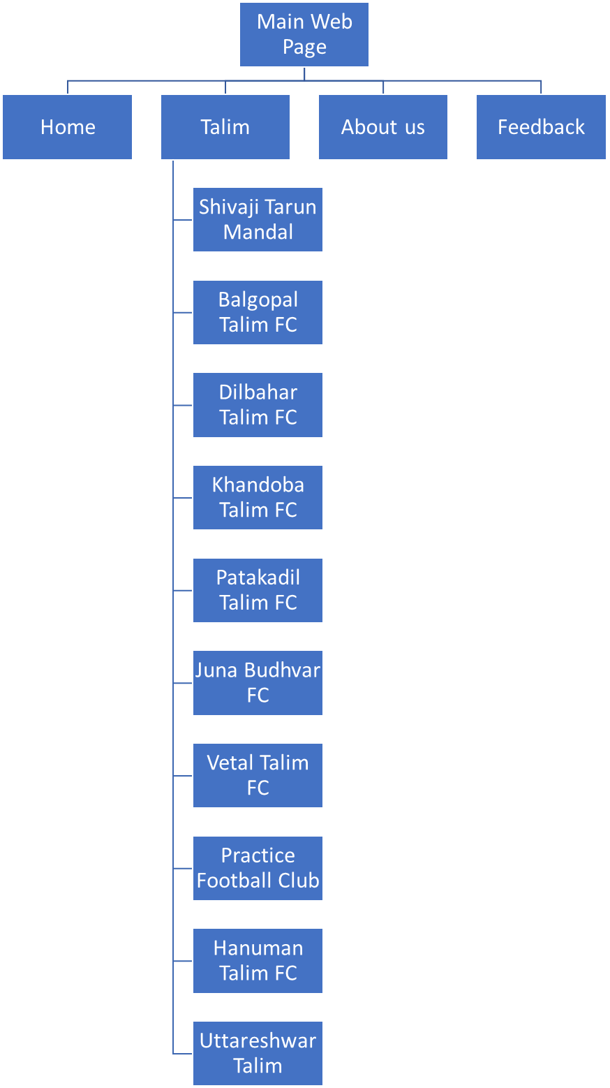

Objectives:

- To provide Teams and player information in Talim.

- To create online presence in public.

- To gather all information on one platform.

Tools & Technology

HTML

HTML serves as the backbone of the Kolhapur Talim website, it providing the structure and content mark-up for web pages. It defines layout of text, images, links, and other media element.

CSS

CSS is used to style and design the visual presentation of the Kolhapur Talim website. It controls the layout, colour scheme, typography and overall aesthetic appeal of web page.

Hardware & Software Requirement

Hardware Requirement :

Intel core i5 8th Gen
16 GB RAM
256 GB SSD
15 inch Laptop Screen
Windows 10 OS

Software Requirement :
Languages used :HTML & CSS language.
Operating system :Windows 10+ Front-End: HTML, CSS.
Browser :Google chrome, Microsoft Edge.
Application :Visual Studio Code.
System type :32,64 bit +

System Analysis

Data Collection :

The Kolhapur Talim project is an initiative aimed at digitizing and preserving the traditional Indian football of Kolhapur, which originated in the Kolhapur region of Maharashtra, India.

The project involves collecting and documenting various aspects of Kolhapur, including its history, techniques, and cultural significance. To achieve this, the project relies on data collection through various methods, such as:

1. Surveys and interviews: Conducting surveys and interviews with Kolhapur practitioners, trainers, and experts to gather information about the art form's history, techniques, and cultural significance.
2. Observational studies: Conducting observational studies of Kolhapur training sessions and performances to gather data on techniques, movements, and training methods.
3. Collection of archival materials: Collecting and digitizing archival materials, such as photographs, videos, and documents related to Kolhapur Talim history and evolution.
4. Ethnographic research: Conducting ethnographic research to study the cultural and social context of Kolhapur practices and their significance in the lives of practitioners and communities.

System Design: Home Page
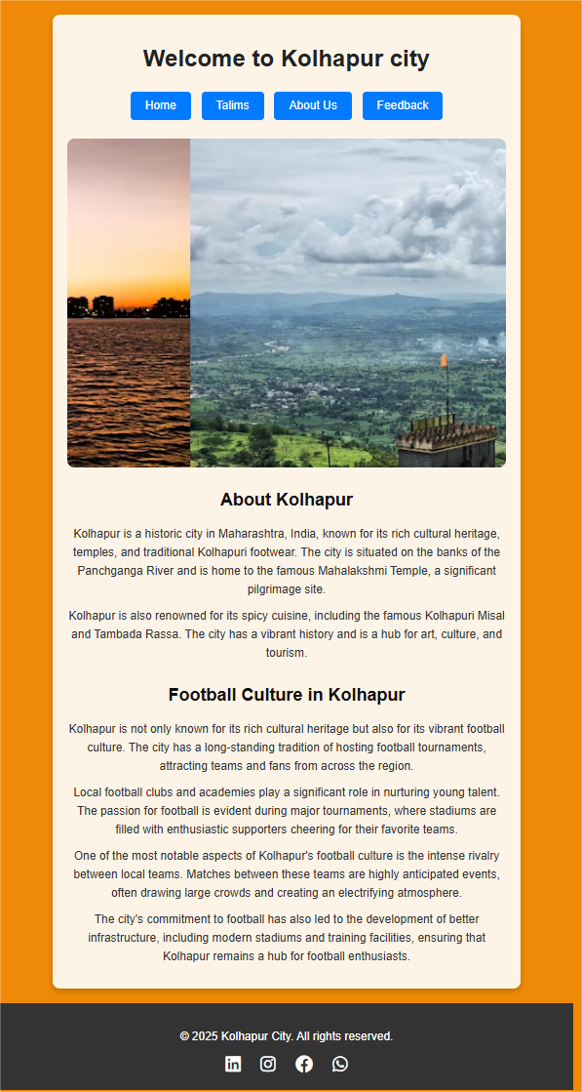
Talim Page:
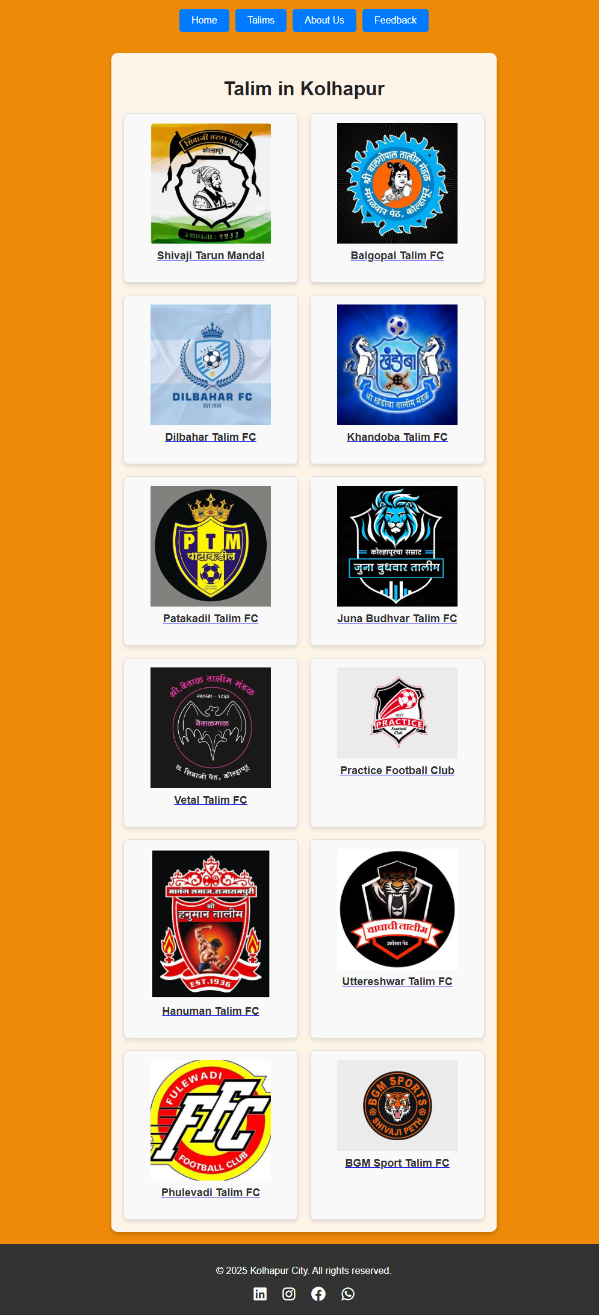
About Us:
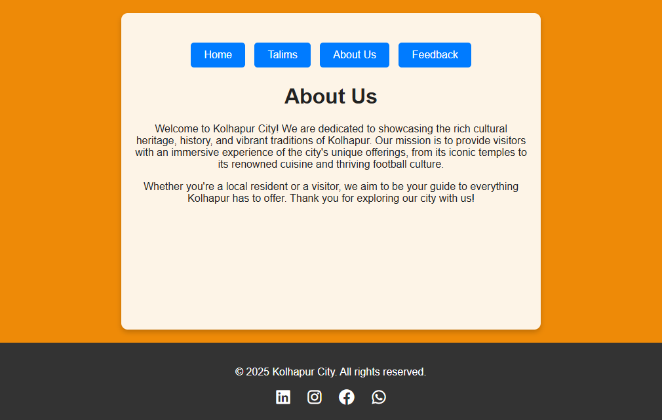
Feedback: 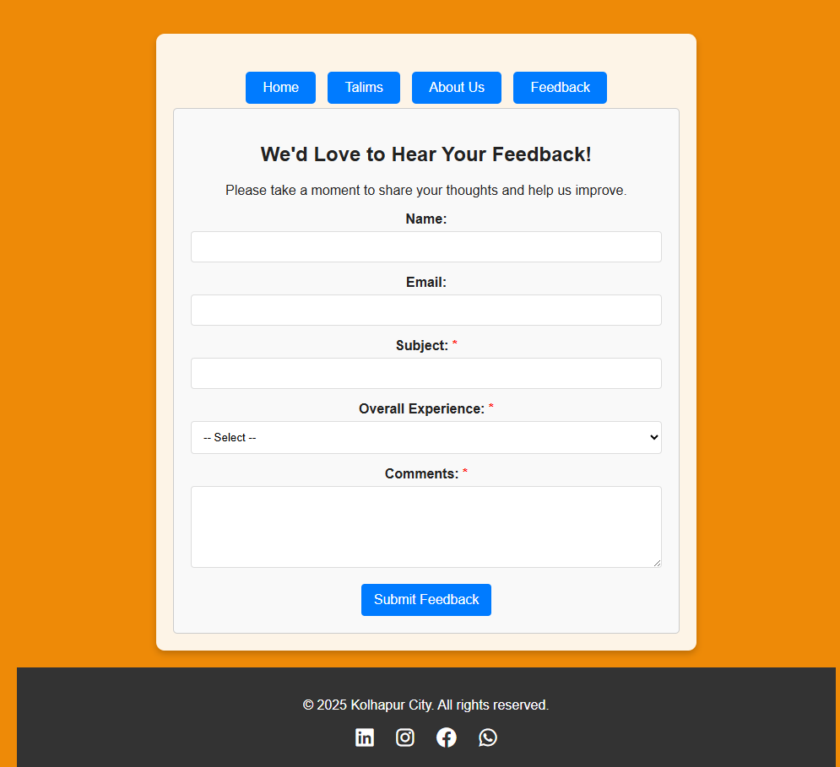
Suggestions :
1. Simple Navigation: Make it easy to find information with clear menus and links.
2. Search Bar: Add a search box so people can quickly find what they need.
3. Event Calendar: Include a calendar for upcoming events and important dates.
4. Contact Info: Provide clear contact details for mandal and friends circles.
5. Attractive Design: Use nice images and a clean layout to make the site look good

Limitation :
Our website plays a crucial role for several reasons. It often gives people their first impression of the Kolhapur, setting the tone for their experience. It also needs to have current and relevant content to keep visitors informed. The website provides essential information, helping visitors to find what we have. By offering a professional and reliable online presence, it helps build trust with prospective. We provides a virtual presence & allowing visitors to explore the Kolhapur from anywhere.

Conclusion :
In conclusion, our website project was a great learning experience and an important step in creating a helpful resource for tourist , and visitors. During this project, we learned about web design, coding, and organizing content. The website acts as a central place for information about friends circles and football in Kolhapur.
Our main goal was to build a user-friendly site that is easy to navigate, informative, and visually attractive. By focusing on clear layouts and easy-to-find information, we aimed to make the online experience better for users, helping them quickly find what they need.

References:
- Google.com
- Respective official members and websites.

